Home Learning
During the school closure it is important that the children continue their learning.
We would like the children to do the following:

Maths
- Know number bonds to 20 and be able to recall all the facts quickly.
e.g. 5 + 4 = 9 8 + 5 = 13 13 + 6 =
- Find fractions of amounts.
e.g. ½ of 18 ¼ of 16, ¾ of 12 1/3 of 15 2/3 of 18
- Learn the 2, 5, 10 times tables and be able to recall all the facts quickly.

- Add and subtract 2 digit numbers.
24 + 22 = 36 + 25 = 37 – 12 = 41 – 15 =
- Recall doubles and halves of numbers up to 20.

- Do some practical maths, such as weighing amounts in g and kg and measuring liquids in ml and l.

Writing
- Write daily in your journal.
- Write a book review of some of the books you have read.
- Use the story starters below to write stories in your writing journal.
Please make sure the children write neatly and in full sentences using a range of conjunctions and punctuation. You could challenge them to include ambitious vocabulary and different types of sentences, such as questions and exclamations.

As she walked out of her room the tiny dragon in her pocket stirred restlessly.

I was woken by the loud roar of an engine and bright lights. An alien had landed.

I pushed open the old creaky door and looked inside. What a sight met my eyes!

Reading
Read daily for a minimum of 15 minutes per day. Please ensure the children are asked lots of questions about what they are reading to develop their comprehension skills, making sure they are asked inference and deduction questions.
Spelling
Practice all of the spellings that the children have learnt so far this year. Please also go over the Year 1 and 2 Common Exception Words that were included in the Easter homework pack.
Science
Do a research project on plants. You could include sections on the following:
- Parts of a plant
- What plants need to grow
- The life cycle of a plant
- The different plants found in different places
Find out as much as you can about a plant of your choice.
Art
We have been learning about the work of Vincent Van Gogh. Create your own picture of Vincent Van Gogh’s picture The Starry Night.

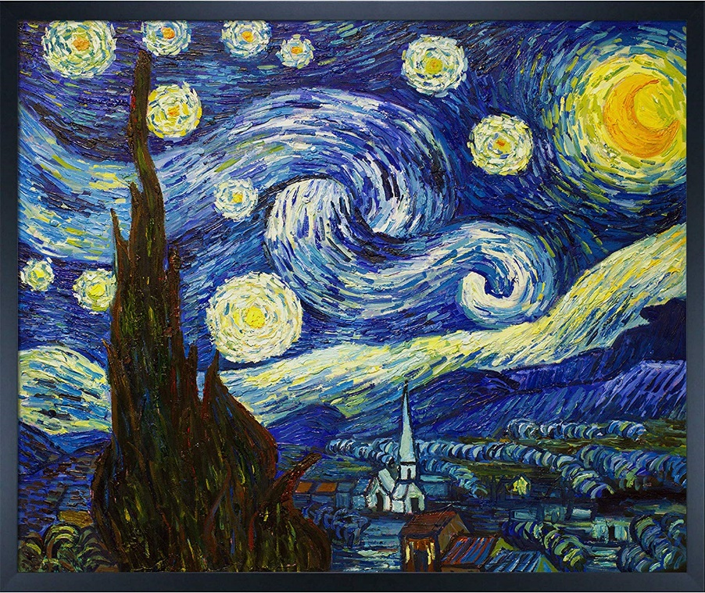

- Useful websites:
- www.topmarks.co.uk
- www.ictgames.com
- https://www.oxfordowl.co.uk/for-home/kids-activities/kids-activities-age-6-7/

