Learning  Behaviour | Destination Reader  Learning Behaviour stems |  |  | How did we do?
Support and actively listen to others |  |  |  | 1 2 3 4
Use supportive facial expressions – nod, smile, agree. Bring quieter people into conversation look at the speaker, listen and respond to what was said | Support | Great reading, good thinking.  I like the way you … when you read.  You’ve really improved in…  What do you think?  That’s a good way to think about it. |  | 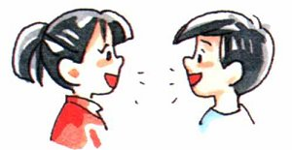  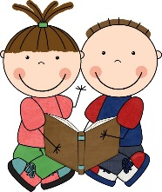
 | Active listening | Good point  That’s interesting  I hadn’t thought of that point.  Can you explain?
Discuss and explain our ideas |  |  |  | 1 2 3 4
Referring back to text and giving extended answers  (Point – Evidence – Explain) | I think this means that … because it says…  On the one hand you could say … but on the other  … is similar to ….. because …..  This character is ….. because …..  The main idea is that ….  In summary… because … |  |  | 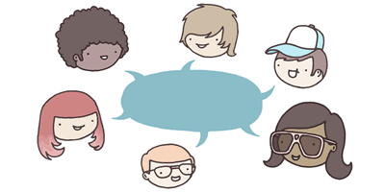
Building on other’s answers | Agreeing |  | I agree with … because …  I’d like to add to that point ….
 | Disagreeing / challenging and offering alternative |  | Or…  It could be but…….  I agree with some aspects of …’s point however  Why do you think that?  What evidence is there that backs up your point?
 | New idea |  | Have we thought about…?  Another point I wish to make is …  On reflection I no longer think that …..
Take responsibility for our own/group’s learning |  |  |  | 1 2 3 4
ensure you took part, made sure everyone understood task and participated | Are we all clear about…?  Does anyone feel they need some more explanation?  We worked well today because we ….  Today didn’t work well because ….  Our target next time should be to … |  |  | 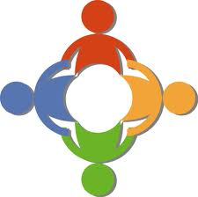

Destination Reader
Predicting | Inferring 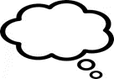
- I wonder if  - I predict  - I think that  - I bet that because  - I imagine  - The next part will be about | - This word tells me  - This part tells me  - This makes me think that  - I think this character because  - I think the setting is
Asking questions | 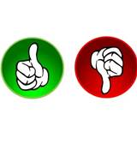  Evaluating
- Who  - What  - When  - Where  - Why?  - How? | Language  - The word/phrase * works well because  - I like the way the author uses * it makes me think about  - The sentence * has high impact because
Clarifying | Making connections 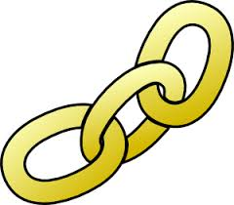
- I think that means  - I didn’t understand  - What does * mean?  - * is a tricky word so I | Text to self:  - I know about this because I  - I’ve been/seen  - I saw a programme about this  - I can identify with this character because  Text to text:  - I think this book is a * (genre) book because  - This reminds me of * because  - This is similar to * because
Summarising
- This part is about  - The heading would be  - The main theme is | Learning Behaviours
- Support and listen to others
- Discuss and explain our ideas
- Take responsibility for your own learning.

