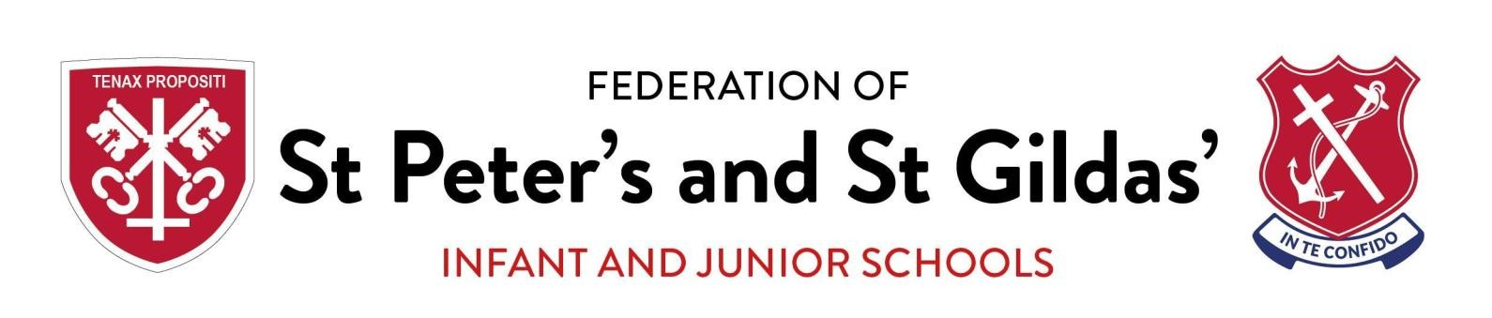
Peer on Peer abuse policy

Updated by | Sinead O’Brien
Governor Responsible | Mrs Brid Daly
Last reviewed | August 2021
Ratified on | August 2022
Review period | Annual
Signed

- Context and definition
- Responsibility
- Purpose of the policy
- Framework and legislation
- Abuse and harmful behaviour
- Types of abuse
  - Physical abuse
  - Sexual violence and sexual harassment
  - Bullying
  - Online bullying
  - Sexting
  - Initiation / hazing
  - Prejudiced behaviour
  - Teenage relationship abuse
- Expected staff action
- Recognising peer abuse
- Points to consider
- Next steps
- Preventative strategies
- Where to go to for further information

1. Context and Definition

It is essential that all staff at St Peter’s and St Gildas’ understand the importance of challenging inappropriate behaviours between peers, many of which are listed below, that are actually abusive in nature. Downplaying certain behaviours, for example dismissing sexual harassment as “just banter”, “just having a laugh”, “part of growing up” or “boys being boys” can lead to a culture of unacceptable behaviours, an unsafe environment for children and in worst case scenarios a culture that normalises abuse leading to children accepting it as normal and not coming forward to report it. (KCSIE 21)

St Peter’s and St Gildas’ staff who work with children are advised to maintain an attitude of ‘it could happen here’ where safeguarding is concerned. When concerned about the welfare of a child, staff should always act in the best interests of the child.

Peer abuse is behaviour by an individual or group, intending to physically, sexually or emotionally hurt others
All staff should recognise that children are capable of abusing their peers.
All staff should be aware of safeguarding issues from peer abuse including:
- bullying (including online bullying)
- physical abuse such as hitting, kicking, shaking, biting, hair pulling, or otherwise causing physical harm
- sexual violence and sexual harassment
- sexting (also known as youth produced sexual imagery); and
- initiation/hazing type violence and rituals.
This abuse can:
- Be motivated by perceived differences e.g. on grounds of race, religion, gender, sexual orientation, disability or other differences
- Result in significant, long lasting and traumatic isolation, intimidation or violence to the victim; vulnerable adults are at particular risk of harm
Children or young people who harm others may have additional or complex needs e.g.:
- Significant disruption in their own lives
- Exposure to domestic abuse or witnessing or suffering abuse
- Educational under-achievement
- Involved in crime
Stopping violence and ensuring immediate physical safety is the first priority of any education setting, but emotional bullying can sometimes be more damaging than physical. School staff, alongside their Designated Safeguarding Lead and/or Deputy, have to make their own judgements about each specific case and should use this policy guidance to help.

2. Responsibility
Keeping Children Safe in Education (KCSIE), 2021 states that
‘Governing bodies and proprietors should ensure their child protection policy includes procedures to minimise the risk of peer on peer abuse and sets out how allegations of peer on peer abuse will be investigated and dealt with’.
It also emphasises that the voice of the child must be heard
‘Governing bodies, proprietors and school or college leaders should ensure the child’s wishes and feelings are taken into account when determining what action to take and what services to provide. Systems should be in place for children to express their views and give feedback. Ultimately, all system and processes should operate with the best interests of the child at their heart.’
Peer on Peer abuse is referenced in the Safeguarding and Child Protection Policy. The sensitive nature and specific issues involved with peer on peer necessitate separate policy guidance.
At St Peter’s and St Gildas’ we continue to ensure that any form of abuse or harmful behaviour is dealt with immediately and consistently to reduce the extent of harm to the young person, with full consideration to the impact on that individual child’s emotional and mental health and well-being.

3. Purpose of Policy
The purpose of this policy is to explore some forms of peer on peer abuse. The policy also
includes a planned and supportive response to the issues.
At St Peter’s and St Gildas’ we have the following policies in place that should be read in conjunction with this policy:
3.1 Anti-Bullying including Online Bullying Policy
3.2 Safeguarding and Child Protection Policy
3.3 Managing Allegations / Whistleblowing Policy
3.4 Behaviour Policy
3.5 Health & Safety Policy
3.6 Online Safety Policy

4. Framework and Legislation
This policy is supported by the key principles of the Children’s Act, 1989 that the child’s welfare is paramount. Another key document is Working Together, 2018, highlighting that every assessment of a child, ‘must be informed by the views of the child’. (Working Together, 2018:21) This is echoed by Keeping Children Safe in Education, 2021 through ensuring procedures are in place in schools and settings to hear the voice of the child.

5 Abuse and harmful behaviour
It is necessary to consider
- what abuse is and what it looks like
- how it can be managed
- what appropriate support and intervention can be put in place to meet the needs of the individual
- what preventative strategies may be put in place to reduce further risk of harm.

Abuse is abuse and should never be tolerated or passed off as ‘banter’ or ‘part of growing up’. It Is important to consider the forms abuse may take and the subsequent actions required.
- Children are vulnerable to abuse by their peers. Such abuse should be taken as seriously as abuse by adults and should be subject to the same child protection procedures.
- Children can abuse other children. This can include (but is not limited to): abuse within intimate partner relationships; bullying (including cyberbullying); sexual violence and sexual harassment; physical abuse such as hitting, kicking, shaking, biting, hair pulling,
or otherwise causing physical harm; sexting and initiation/hazing type violence and rituals.
Abuse is abuse and should never be tolerated or passed off as ‘banter’ or ‘part of growing up’. It is important to consider the forms abuse may take and the subsequent actions required.
- Children are vulnerable to abuse by their peers. Such abuse should be taken as seriously as abuse by adults and should be subject to the same child protection procedures.
- Children can abuse other children. This can include (but is not limited to): abuse within intimate partner relationships; bullying (including cyberbullying); sexual violence and sexual harassment; physical abuse such as hitting, kicking, shaking, biting, hair pulling, or otherwise causing physical harm; sexting and initiation/hazing type violence and rituals.
- Staff should not dismiss abusive behaviour as normal between young people and should not develop high thresholds before taking action.
- Staff should be aware of the potential uses of information technology for bullying and abusive behaviour between young people.
- Staff should be aware of the added vulnerability of children and young people who have been the victims of violent crime (for example mugging), including the risk that they may respond to this by abusing younger or weaker children.
The alleged perpetrator is likely to have considerable unmet needs as well as posing a significant risk of harm to other children. Evidence suggests that such children may have suffered considerable disruption in their lives, may have witnessed or been subjected to physical or sexual abuse, may have problems in their educational development and may have committed other offences. They may therefore be suffering, or be at risk of suffering, significant harm and be in need of protection. Any long-term plan to reduce the risk posed by the alleged perpetrator must address their needs.

6. Types of abuse
There are many forms of abuse that may occur between peers and this list is not exhaustive. Each form of abuse or prejudiced behaviour is described in detail followed by advice and support on actions to be taken.

6.1 Physical abuse
This may include hitting, kicking, nipping/pinching, shaking, biting, hair pulling, or otherwise causing physical harm to another person. There may be many reasons why a child harms another and it is important to understand why a young person has engaged in such behaviour, including accidently before considering the action or punishment to be undertaken.

6.2 Sexual violence and sexual harassment
This must always be referred immediately to the Designated Safeguarding Lead
The DSL will follow the DfE Guidance: Sexual violence and sexual harassment between children in schools and colleges Sept 2021 https://assets.publishing.service.gov.uk/government/uploads/system/uploads/attachm ent_data/file/999239/SVSH_2021.pdf
with consideration of
• | Managing internally | 65.1, page 27
• | Early Help | 65.2, page 28
• | MASH referral | 65.3. page 28
- Reporting to the police 65.4, Page 29
Sexual violence and sexual harassment can occur between two children of any age and sex. It can also occur through a group of children sexually assaulting or sexually harassing a single child or group of children.
Sexually harmful behaviour from young people is not always contrived or with the intent to harm others. There may be many reasons why a young person engages in sexually harmful behaviour and it may be just as distressing to the young person who instigates it as to the young person it is intended towards. Sexually harmful behaviour may include
- inappropriate sexual language
- inappropriate role play
- sexual touching
- sexual assault/abuse.
Staff should be aware of the importance of:
- making clear that sexual violence and sexual harassment is not acceptable, will never be tolerated and is not an inevitable part of growing up
- not tolerating or dismissing sexual violence or sexual harassment as “banter”,
“part of growing up”, “just having a laugh” or “boys being boys”; and
- challenging behaviours (potentially criminal in nature), such as grabbing bottoms, breasts and genitalia, flicking bras and lifting up skirts. Dismissing or tolerating such behaviours risks normalising them
- Upskirting: where someone takes a picture under a person’s clothing (not necessarily a skirt) without permission and or knowledge, with the intention of viewing their genitals or buttocks (with or without underwear) to obtain sexual gratification, or cause the victim humiliation, distress or alarm. It is acriminal offence. Anyone of any gender, can be a victim.

6.3 Bullying
Bulling is unwanted, aggressive behaviour among school aged children that involves a real or perceived power imbalance. The behaviour is repeated, or has the potential to be repeated, over time. Both young people who are bullied and who bully others may have serious, lasting problems.
In order to be considered bullying, the behaviour must be aggressive and include:
- An Imbalance of Power: Young people who bully use their power—such as physical strength, access to embarrassing information, or popularity—to control or harm others. Power imbalances can change over time and in different situations, even if they involve the same people.
- Repetition: Bullying behaviours happen more than once or have the potential to happen more than once.
Bullying includes actions such as making threats, spreading rumours, attacking someone physically or verbally or for a particular reason e.g. size, hair colour, gender, sexual orientation, and excluding someone from a group on purpose.

6.4 Online Bulling

Online Bullying is the use of technology (social networking, messaging, text messages, e- mail, chat rooms etc.) to harass threaten or intimidate someone for the same reasons as stated above.
Online bullying can take many forms
- Abusive or threatening texts, emails or messages
- Posting abusive comments on social media sites
- Sharing humiliating videos or photos of someone else
- Stealing someone’s online identity
- Spreading rumours online
- Trolling – sending someone menacing or upsetting messages through social networks, chatrooms or games
- Developing hate sites about another person
- Prank calls or messages
- Group bullying or exclusion online
- Anonymous messaging
- Encouraging a young person to self-harm
- Pressuring children to send sexual messages or engaging in sexual conversations

6.5 Sexting / Sharing nude or indecent imagery

The term ‘sexting’ relates to the sending of indecent images, videos and/or written messages with sexually explicit content; these are created and sent electronically. They are often ‘shared’ via social networking sites and instant messaging services.
Upskirting: typically involves taking a picture under a person’s clothing without them knowing, with the intention of viewing their genitals or buttocks to obtain sexual gratification, or cause the victim humiliation, distress or alarm. It is a criminal offence. Anyone of any gender, can be a victim. This must always be referred immediately to the Designated Safeguarding Lead DSL will follow the UKCIS: Sexting in schools and colleges 2016 guidance.
https://www.gov.uk/government/uploads/system/uploads/attachment_data/file/551575/6.243 9_KG_NCA_Sexting_in_Schools_WEB 1_.PDF

6.6 Initiation/Hazing

Hazing is a form of initiation ceremony which is used to induct newcomers into an organisation such as a private school, sports team etc. There are a number of different forms, from relatively mild rituals to severe and sometimes violent ceremonies. The ceremony welcomes newcomers by subjecting them to a series of trials which promote a bond between them. After the hazing is over, the newcomers also have something in common with older members of the organisation, because they all experienced it as part of a rite of passage. Many rituals involve humiliation, embarrassment, abuse, and harassment.

6.7 Prejudiced Behaviour

The term prejudice-related bullying refers to a range of hurtful behaviour, physical or emotional or both, which causes someone to feel powerless, worthless, excluded or marginalised, and which is connected with prejudices around belonging, identity and equality in wider society – for example disabilities and special educational needs, ethnic, cultural and religious backgrounds, gender, home life, (for example in relation to issues of care, parental occupation, poverty and social class) and sexual identity.

6.8 Teenage relationship abuse
Teenage relationship abuse is a pattern of actual or threatened acts of physical, sexual, and/or emotional abuse, perpetrated by an adolescent (between the ages of 13 and 18) against a current or former partner. Abuse may include insults, coercion, social sabotage, sexual harassment, threats and/or acts of physical or sexual abuse. The abusive teen uses this pattern of violent and coercive behaviour, in a heterosexual or same gender relationship, in order to gain power and maintain control over the partner. This abuse may be child sexual exploitation.

7. Expected staff action

Staff should consider the seriousness of the case and make a quick decision whether to inform the Designated Safeguarding Lead immediately before taking any further in-school actions.

8. Recognising peer abuse

An assessment of an incident between peers should be completed and consider:
- Chronological and developmental ages of everyone involved
- Difference in their power or authority in relation to age, race, gender, physical, emotional or intellectual vulnerability
- All alleged physical and verbal aspects of the behaviour and incident
- Whether the behaviour involved inappropriate sexual knowledge or motivation
- What was the degree of physical aggression, intimidation, threatening behaviour or bribery
- The effect on the victim
- Any attempts to ensure the behaviour and incident is kept a secret
- The child or young person’s motivation or reason for the behaviour, if they admit that it occurred
- Whether this was a one-off incident, or longer in duration
It is important to deal with a situation of peer abuse immediately and sensitively. It is necessary to gather the information as soon as possible to get the true facts. It is equally important to deal with it sensitively and think about the language used and the impact of that language on both the children and the parents when they become involved. Avoid language that may create a ‘blame’ culture and leave a child labelled.
Staff will talk to the children in a calm and consistent manner. Staff will not be prejudiced, judgmental, dismissive or irresponsible in dealing with such sensitive matters.

8.1 Taking Action

- Always take complaints seriously
- Gain a statement of facts from the pupil(s)
- Assess needs of victim and alleged perpetrator
- Consider referral to Police or Social Care
- Contribute to multi-agency assessments
- Convene a risk management meeting
- Record all incidents and all action taken

8.2 Recording sexualised behaviour

- Be clear, explicit and non-avoidant, and avoid vague statements or euphemisms
- Record as soon as possible, as you can quickly forget or confuse detail
- Follow the prompts on your safeguarding and child protection recording form
- Use proper names for body parts but record exactly any language or vocabulary used by the child. Use the child’s exact words in quotation marks.
- Note where and when the incident happened and whether anyone else was around.

8.3 Gather the Facts

Speak to all the young people involved separately, gain a statement of facts from them and use consistent language and open questions for each account. Ask the young people to tell you what happened. Use open questions, ‘where, when, why, who’. (What happened? Who observed the incident? What was seen? What was heard? Did anyone intervene?). Do not interrogate or ask leading questions.

8.4 Consider the Intent

Has this been a deliberate or contrived situation for a young person to be able to harm another?

8.5 Decide on your next course of action

If you believe any young person to be at risk of significant harm you must report to the Designated Safeguarding Lead immediately; they will follow the school’s Safeguarding and Child Protection Policy.
If MASH and the police intend to pursue this further, they may ask to interview the young people in school or they may ask for parents to come to school to be spoken to. It is important to be prepared for every situation and the potential time it may take.

8.6 Informing parents/carers
The best way to inform parents/carers is face to face. Although this may be time consuming, the nature of the incident and the type of harm/abuse a young person may be suffering can cause fear and anxiety to parents/carers whether their child is the child who was harmed or who harmed another.
Is the pupil 13+ and does not want to share with parents? Use the ‘Gillick’ test and the ‘Fraser’ guidelines.
https://www.nspcc.org.uk/preventing-abuse/child-protection-system/legal-definition-child- rights-law/gillick-competency-fraser-guidelines/
In all circumstances where the risk of harm to the child is evident then the school should encourage the young person to share the information with their parent/carer (they may be scared to tell parents/carers that they are being harmed in any way).

9. Points to consider

9.1 What is the age of the children involved?

How old are the young people involved in the incident and is there any age difference between those involved? In relation to sexual exploration, children under the age of 5, in particular 1-4 year olds who are learning toileting skills may show a particular interest in exploration at around this stage. This, however, should not be overlooked.

9.2 Where did the incident or incidents take place?

Was the incident in an open, visible place to others? If so, was it observed? If not, is more, supervision required within this particular area?
9.3 What was the explanation by all children involved of what occurred?
Can each of the young people give the same explanation of the incident and also what is the effect on the young people involved? Is the incident seen to be bullying for example, in which case regular and repetitive? Is the version of one young person different from another and why?
9.4 What is each of the children’s own understanding of what occurred?
Do the young people know/understand what they are doing? E.g. do they have knowledge of body parts, of privacy and that it is inappropriate to touch? Is the young person’s explanation in relation to something they may have heard or been learning about that has prompted the behaviour? Is the behaviour deliberate and contrived? Does the young person have understanding of the impact of their behaviour on the other person?

9.5 Repetition
Has the behaviour been repeated to an individual on more than one occasion? In the same way it must be considered has the behaviour persisted to an individual after the issue has already been discussed or dealt with and appropriately resolved?

10. Next Steps

Once the outcome of the incident(s) has been established it is necessary to ensure future incidents of abuse do not occur again and consider the support and intervention required for those involved

10.1 For the young person who has been harmed

What support they require depends on the individual young person. It may be that they wish to seek counselling or one to one support via a mentor. It may also be that they feel able to deal with the incident(s) on their own or with support of family and friends; in which case it is necessary that this young person continues to be monitored and offered support should they require it in the future. If the incidents are of a bullying nature, the young person may need support in improving peer groups/relationships with other young people, or some restorative justice work with all those involved may be required.
Other interventions that could be considered may target a whole class or year group for example a speaker on online bullying, relationship abuse etc. It may be that through the

10.2 For the young person who has displayed harmful behaviour

It is important to find out why the young person has behaved in such a way. It may be that the young person is experiencing their own difficulties and may even have been harmed themselves in a similar way. In such cases support such as one to one mentoring or counselling may also be necessary.
Particular support from identified services may be necessary through an early help referral and the young person may require additional support from family members.
Once the support required to meet the individual needs of the young person has been met, it is important that the young person receives a consequence for their behaviour. This may be in the form of restorative justice e.g. making amends with the young person they have targeted if this has been some form of bullying. In the cases of sexually harmful behaviour it may be a requirement for the young person to engage in one to one work with a particular service or agency (if a crime has been committed this may be through the police or youth offending service). If there is any form of criminal investigation ongoing it may be that this young person cannot be educated on site until the investigation has concluded. In which case, the young person will need to be provided with appropriate support and education elsewhere.
It may be that the behaviour that the young person has displayed may continue to pose a risk to others, in which case an individual risk assessment may be required. This should be completed via a multi- agency response to ensure that the needs of the young person and the risks towards others are measured by all of those agencies involved including the young person and their parents. This may mean additional supervision of the young person or protective strategies if the young person feels at risk of engaging in further inappropriate or harmful behaviour.
The school may also choose a punishment as a consequence such as exclusion or internal exclusion/inclusion/seclusion for a period of time to allow the young person to reflect on their behaviour.

10.3 After care
It is important that following the incident the young people involved continue to feel supported and receive help even if they have stated that they are managing the incident. Sometimes the feelings of remorse, regret or unhappiness may occur at a much later stage than the incident. It is important to ensure that the young people do not engage in any further harmful behaviour either towards someone else or to themselves as a way of coping (e.g. self-harm). For this reason, regular reviews with the young people following the incident(s) are imperative.

11. Preventative Strategies

Peer on peer abuse can and will occur on any site even with the most robust policies and support processes. It is important to develop appropriate strategies to proactively prevent peer on peer abuse.
This school has an open environment where young people feel safe to share information about anything that is upsetting or worrying them. There is a strong and positive PSHE/RSHE curriculum that tackles such issues as prejudiced behaviour and gives children an open forum to talk things through rather than seek one on one opportunities to be harmful to one another. The school makes sure that ‘support and report’ signposting is available to young people.
Staff will not dismiss issues as ‘banter’ or ‘growing up’ or compare them to their own experiences of childhood. Staff will consider each issue and each individual in their own right before taking action.
Young people are part of changing their circumstances and, through school council and pupil voice for example, we encourage young people to support changes and develop ‘rules of acceptable behaviour’. We involve pupils in the positive ethos in school; one where all young people understand the boundaries of behaviour before it becomes abusive.
https://www.nspcc.org.uk/globalassets/documents/publications/harmful-sexual-behaviour- framework.pdf
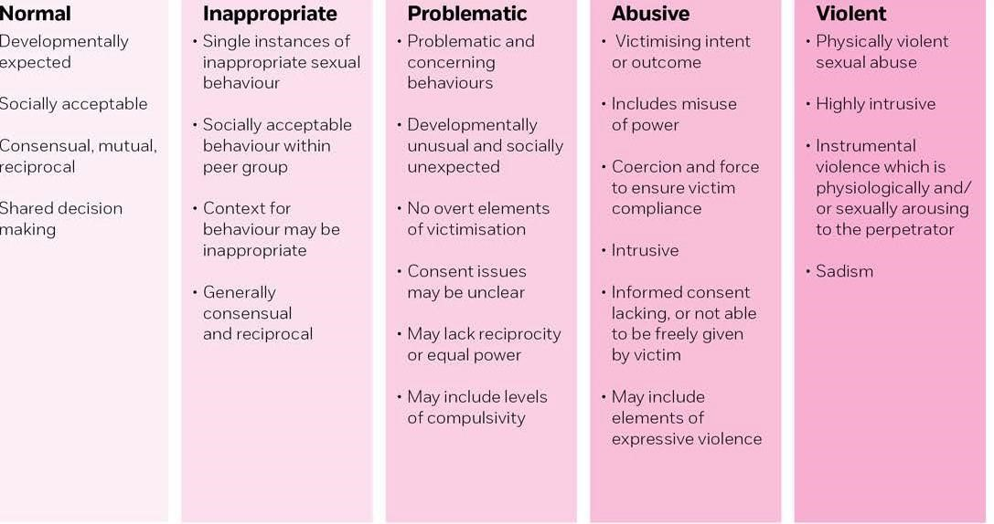
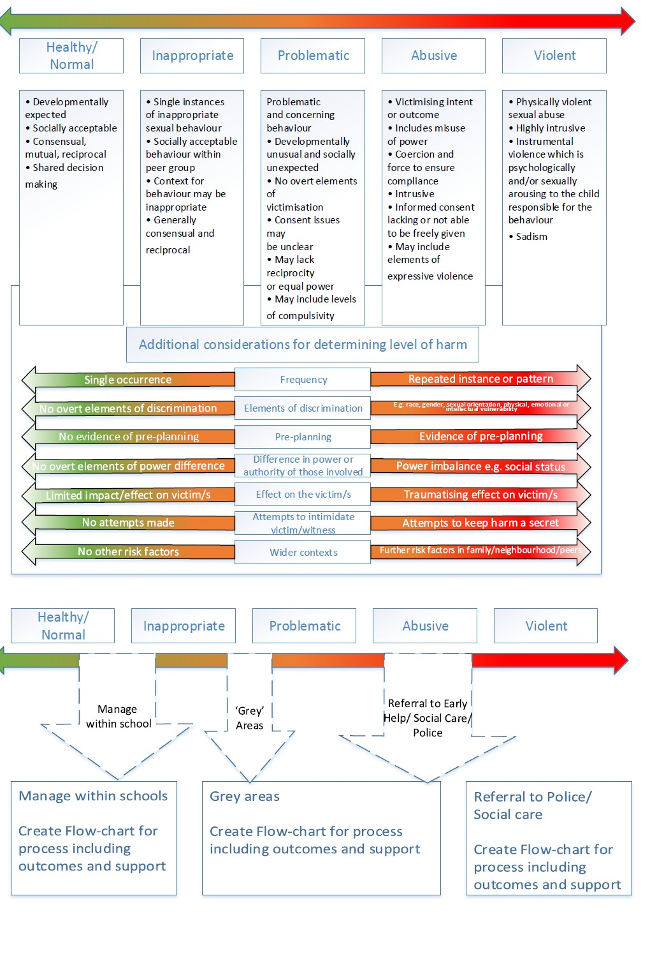
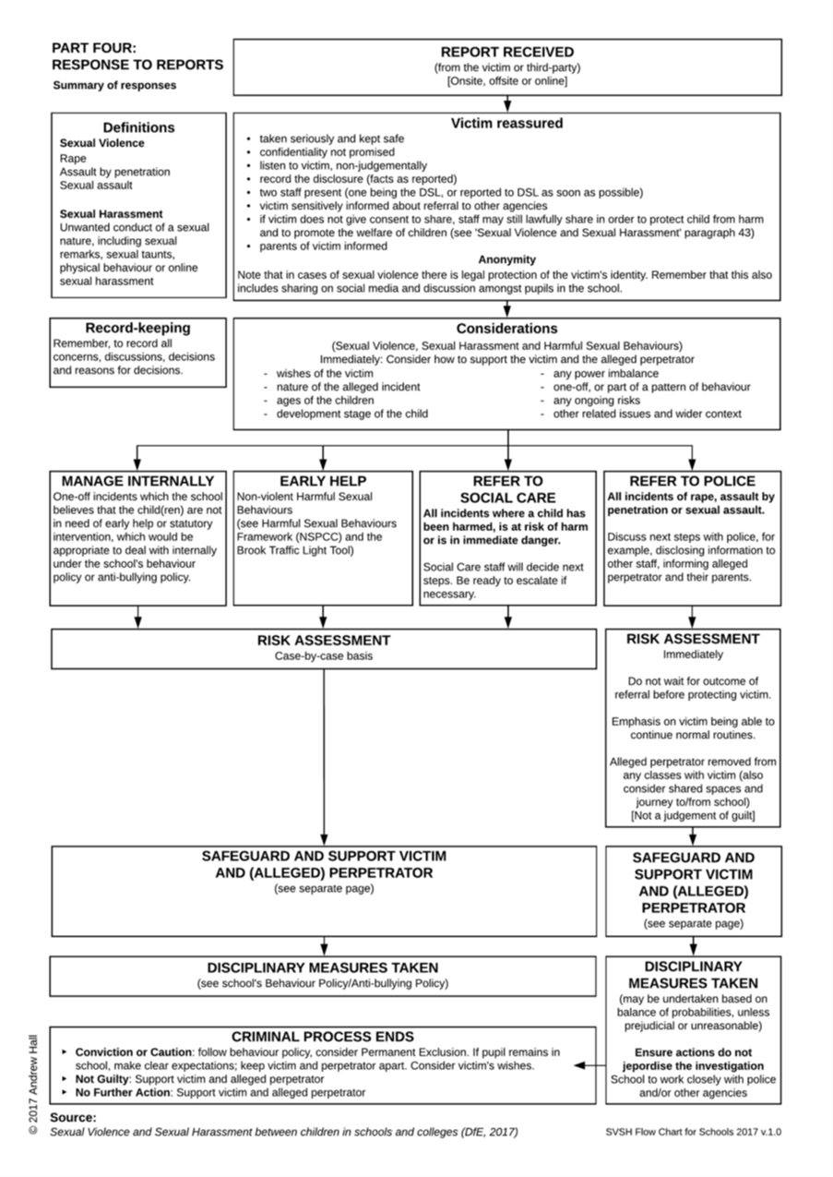

12. Where to go for further information

11.1. DfE: Statutory guidance: Working together to safeguard children, 2018 https://www.gov.uk/government/publications/working-together-to-safeguard-children--2
11.2. DfE: Statutory guidance: Keeping children safe in education, September 2020 https://www.gov.uk/government/publications/keeping-children-safe-in-education--2
11.3. DfE Guidance: Sexual violence and sexual harassment between children in schools and colleges, May 2018
https://www.gov.uk/government/publications/sexual-violence-and-sexual-harassment- between-children-in-schools-and-colleges
11.4. DfE: Searching, screening and confiscation at school, January 2018 https://www.gov.uk/government/publications/searching-screening-and-confiscation
11.5. DfE: Preventing and Tackling Bullying, July 2017 https://www.gov.uk/government/publications/preventing-and-tackling-bullying
11.6. DfE: Statutory guidance School exclusion, May 2020 https://www.gov.uk/government/publications/school-exclusion
11.7. DfE: Teaching Online Safety in Schools, June 2019 https://www.gov.uk/government/publications/teaching-online-safety-in-schools
11.8. DfE: Relationship Education and Relationship and Sex Education, July 2020 https://www.gov.uk/government/publications/relationships-education-relationships-and-sex- education-rse-and-health-education
11.9. DfE: Behaviour and discipline in schools, July 2020 https://www.gov.uk/government/publications/behaviour-and-discipline-in-schools
11.10. DfE: Mental health and behaviour in schools, November 2018 https://www.gov.uk/government/publications/mental-health-and-behaviour-in-schools--2
11.11. DfE: Children Missing Education, September 2016 https://www.gov.uk/government/publications/children-missing-education
11.12. DfE: Cyberbullying: Advice for headteachers and school staff, November 2014 https://assets.publishing.service.gov.uk/government/uploads/system/uploads/attachment_d ata/file/374850/Cyberbullying_Advice_for_Headteachers_and_School_Staff_121114.pdf
11.13. DfE: Mental health and behaviour in schools, November 2018 https://www.gov.uk/government/publications/mental-health-and-behaviour-in-schools--2
11.14. UKCIS: Sexting guidance for schools, 2016 https://www.gov.uk/government/publications/sexting-in-schools-and-colleges
(An updated copy of this guidance is due autumn term 2020)
11.15. UKCIS: Tackling race and faith targeted bullying face to face and online. May 2017 https://www.gov.uk/government/publications/tackling-race-and-faith-targeted-bullying-face- to-face-and-online-a-guide-for-schools
11.16. UKCIS: Education for a connected world, June 2020
https://www.gov.uk/government/publications/education-for-a-connected-world
11.17. London Child Protection Procedures, edition 5, 2018 http://www.londoncp.co.uk/
11.18. Havering: Online CSE toolkit https://www.havering.gov.uk/Pages/Services/Sexual-exploitation.aspx
11.19. Brook Traffic Light Tool https://www.brook.org.uk/training/wider-professional-training/sexual-behaviours-traffic-light- tool/
11.20. Gov.uk: Equality Act 2010: advice for schools https://www.gov.uk/government/publications/equality-act-2010-advice-for-schools
11.21. Equality and Human Rights Commission: Public Sector Equality Duty Guidance for Schools in England
https://www.equalityhumanrights.com/en/publication-download/public-sector-equality-duty- guidance-schools-england
11.22. Key messages from research on children and young people who display harmful sexual behaviour (PDF)
https://www.csacentre.org.uk/index.cfm/_api/render/file/?method=inline&fileID=E2C17C42- 5084-47CC-902E94451079C6B6
11.23. NPCC- When to call the police https://www.npcc.police.uk/documents/Children%20and%20Young%20people/When%20to %20call%20police%20guidance%20for%20schools%20and%20colleges.pdf

